How to setup and configure the Unified Hub
Version: 1.0
Date: 2016-11-08
Creator: Levi Turner

Disclaimer:
Please be aware that this document is not supported and is meant only as a guide. Individual environments may require adjustments for things to work correctly. This will/may require altering and customizing code shipped with QlikView Server/Sense Enterprise. All customization is done at your own risk and is not covered by Qlik Support or Maintenance Agreements. Please backup any files prior to modification.

Table of Contents
1 Introduction 2
2 Qlik Sense configuration 2
2.1 Configuring the Qlik Sense Repository to accept connections from Publisher 2
2.2 Configuring security rules to allow users to view QlikView documents 2
2.3 Exporting the certificates for the Publisher machine to establish trust 3
3 QlikView configuration 4
3.1 Importing the Qlik Sense certificates 4
3.2 Configuring Publisher to communicate with Qlik Sense 5
3.3 Configuring the Distribution task to distribute to Qlik Sense 6
4 Validation & limitations 6
4.1 Validation 6
4.2 Limitations 6

Introduction
In Qlik Sense v3 / QlikView 12 SR3 and higher, there is functionality inside of Qlik Sense and QlikView to publish links to QlikView apps on the Qlik Sense Hub. This functionality is called the Unified Hub and this article will discuss how to setup and configure both QlikView and Qlik Sense to use this functionality.

Qlik Sense configuration
In order for the server running QlikView Distribution Service (Publisher or QDS) to connect to the Qlik Sense machine, three settings need to be changed on the Qlik Sense server:

Configuring the Qlik Sense Repository to accept connections from Publisher
Starting with all Qlik Sense services in a stopped state, complete these steps:
- Open Notepad.exe (or your preferred text editor on the server) as administrator
- Open the Repository.exe.config file in Notepad
  - By default this file is located in C:\Program Files\Qlik\Sense\Repository\Repository.exe.config but this file will live in the install location for Qlik Sense, which is configurable.
- Change the SharedContentEnabled key present in the config file from false to true, like so:
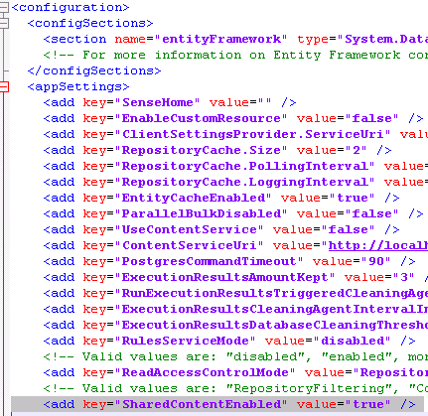
- Save the file
- Start Qlik Sense services

Configuring security rules to allow users to view QlikView documents
The next step will be to configure the appropriate security rule in order to allow users to view the documents which will be published.
- In the QMC, go into the Security rules section, and select Create new to create a new security rule
- Give the security rule a name (in this example it is named Unified Hub (from QVS))
- For the Resource filter, use the filter SharedContent_*
- For the Action, grant the action Create
- For the Condition, enter the condition that you want to use. In the example below of this security rule I am granting access to all users but further customization here may be needed depending on the use case for the environment
- For the Context, set to Only in hub.
- An example of this security rule is as follows:
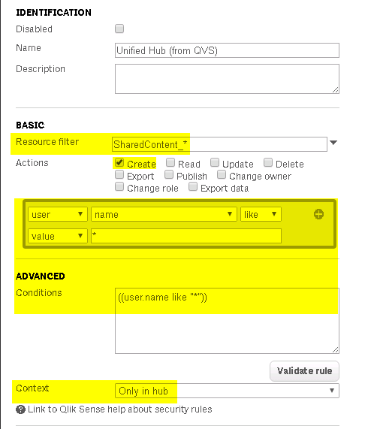

Exporting the certificates for the Publisher machine to establish trust
The next step will be to export a set of certificates from Qlik Sense for use by the Publisher machine for use in establishing trust for the distribution.
- In the QMC, go to the Certificates section
- Under Machine name enter the fully qualified domain name (FQDN) of the server running the QlikView Distribution Service
- Enter a password you would prefer to do so.
- Select the checkbox to include the secrets key on the exported certificate
- Use the default option of using Windows format for the exported certificates
- Select Export certificates
- Navigate to C:\ProgramData\Qlik\Sense\Repository\Exported Certificates and copy the exported certificates to the server running QlikView Distribution Service.

Example screen:
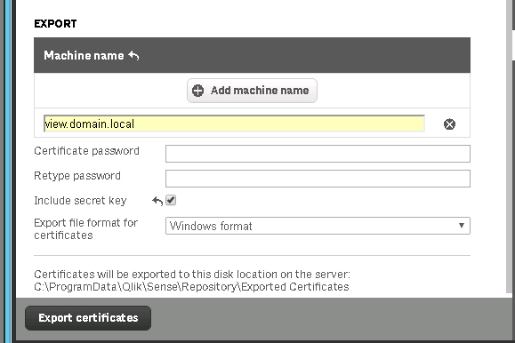

QlikView configuration

Importing the Qlik Sense certificates
On the Publisher server:
- Login as the service account / run MMC as the service account
  - You can use the runas /user:domain\username mmc command in cmd.exe if you need to execute MMC as the service account
  - See this Technet article for more background on the runas command: https://technet.microsoft.com/en-us/library/cc771525(v=ws.11).aspx
- In MMC: File > Add/Remove Snapin > Certificates > My user account > Finish > OK
- Right click on Personal for the Current User > All Tasks > Import
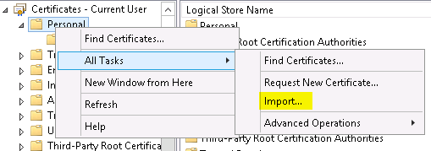
- Navigate to the client.pfx file and import it
  - It’s a good idea to make all certificates exportable by selecting the Mark this key as exportable, but not required for this configuration
- Repeat the import steps for the server.pfx file
- Now select the Trusted Root Certificates section and import the root.cer certificate
- Once all the certificates are installed, go back to the QlikClient certificate in the Personal section and double click on it. This will open the properties of the certificate.
- Now go to the Details tab and scroll to the thumbprint. Copy this value to a notepad window
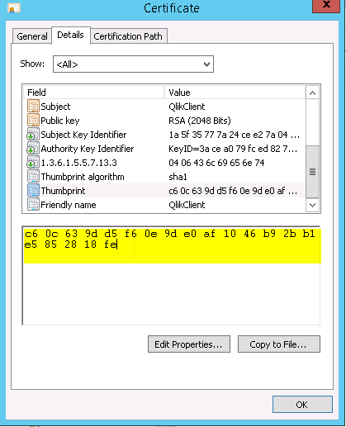

Configuring Publisher to communicate with Qlik Sense
- Stop the QlikView Distribution Service
- Open notepad as an administrator
- Open the Distribution Service config file
  - By default it is located at C:\Program Files\QlikView\Distribution Service\QVDistributionService.exe.config
- Add the following keys inside of the <appSettings> section:
  - <add key="QRSMachineName" value="FQDNofTheSenseServer" />
  - <add key="SenseClientCertificateThumbprint" value="‎ThumbPrintOfTheQlikClientCertificate" />
    - Note that sometimes a non-unicode character can be entered when directly copying from MMC; pasting this thumbprint to a separate notepad window then copying from that notepad window should avoid this
  - <add key="QVWSMachineName" value="the value for the server connection in QMC > System > QVWS > Select QVWS > AccessPoint > Server Connections > Name " />
- The resulting file will look like this:
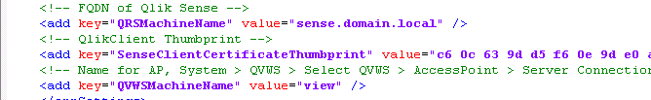
- Start QDS

Configuring the Distribution task to distribute to Qlik Sense
- Setup a distribution task to distribute to Named Users and specify the users or groups
- On the Document Information Tab on the distribution task, add in the following attribute:
  - Name: ShowInSenseHub
  - Value: True
- Run distribution task

Validation & limitations

Validation
At this point the distribution should complete successfully and now you should validate that things appear as expected on the Qlik Sense side. Assuming that you’ve distributed the document to at least the user account that you are using then you should see the document appear in the QlikView documents section of the Hub which should have magically appeared:
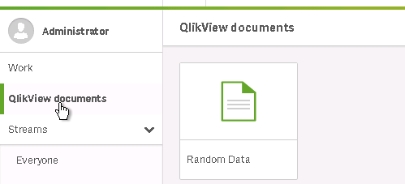
If you are encountering further issues, then contact Qlik Support for a deeper level of troubleshooting.

Limitations
Currently it is not possible to unpublish from the Qlik Sense Hub. As a work-around, you can modify the distribution task to distribute only to a single administrative user which will remove the links to the QlikView documents from other user’s view.

